9.2 Editors - UV Editor - Tool Shelf
Tool Shelf in View Mode 3
Select Tools Group 3
Tweak 3
Select Box 3
Tool Settings 3
Mode 3
Set a new selection 3
Extend existing selection 3
Subtract existing selection 3
Select Circle 3
Tool Settings 4
Mode 4
Set a new selection 4
Extend existing selection 4
Subtract existing selection 4
Radius 4
Select Lasso 4
Tool Settings 4
Mode 4
Set a new selection 4
Extend existing selection 4
Subtract existing selection 4
Cursor 4
Move 5
Snapping 5
Precision movement 5
Header Values 5
Move without widget 5
Limit Axis 5
Last Operator Move 5
Move X, Y Z 5
Orientation 6
Proportional editing 6
Proportional Falloff 6
Proportional Size 6
Connected 6
Projected(2D) 6
Rotate 6
Snapping 6
Precision rotation 6
Header Values 6
Rotate without widget 7
Limit Axis 7
Last Operator Rotate 7
Angle 7
Axis 7
Orientation 7
Proportional editing 7
Proportional Falloff 7
Proportional Size 7
Connected 7
Projected(2D) 7
Scale 8
Snapping 8
Precision Scale 8
Header Values 8
Scale without widget 8
Limit Axis 8
Last Operator Resize 8
Angle 8
Axis 8
Orientation 8
Proportional editing 9
Proportional Falloff 9
Proportional Size 9
Connected 9
Projected(2D) 9
Transform 9
Annotate Tools group 9
Annotate 10
Annotate Line 10
Annotate Polygon 10
Tool Settings 10
Color 10
Note 10
Annotations list 10
Edit Box 10
Fake User 10
Add Annotation 11
Unlink Annotation 11
Thickness 11
Frame Locked/Unlocked 11
Delete Active Frame 11
Thickness 11
Annotate Eraser 11
Tool Settings 11
Radius 11
Grab 11
Relax 12
Pinch 12

Tool Shelf in View Mode

Select Tools Group
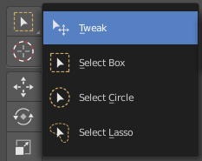
Tools with a triangle down right are a group of tools. Click and hold to reveal the content. Then choose the tool that you need.

Tweak
Allows you to select or tweak single elements by clicking at it.

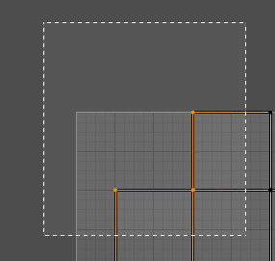
Select Box
Draws a box to select several elements at once. Click at the start point, then drag.

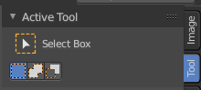
Tool Settings

Mode
The available selection modes. The mode titles are pretty self explaining. So i won't go into detail here.

Set a new selection

Extend existing selection

Subtract existing selection

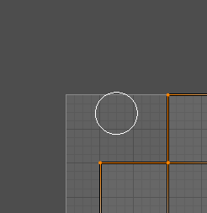
Select Circle
Draws a box to select several elements at once. Click at the start point, then drag.

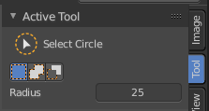
Tool Settings

Mode
The available selection modes. The mode titles are pretty self explaining. So i won't go into detail here.

Set a new selection

Extend existing selection

Subtract existing selection

Radius
The brush radius.

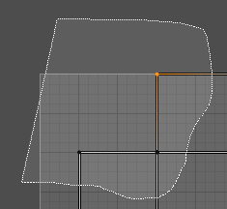
Select Lasso
Draws a box to select several elements at once. Click at the start point, then drag.

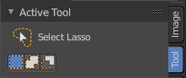
Tool Settings

Mode
The available selection modes. The mode titles are pretty self explaining. So i won't go into detail here.

Set a new selection

Extend existing selection

Subtract existing selection

Cursor
The cursor tool allows you to move the 2d cursor around.

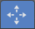
Move
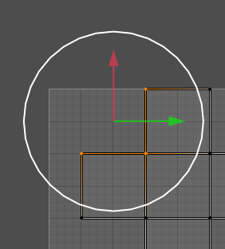
Activates the move tool. Activating the move tool also reveals a move widget at the object. This widget allows you to move the object around, by using the corresponding axis.
When you click at one of the square buttons at the icon, then you can move the object along the plane of the two adjacent axis. The rectangle buttons between the arrows allows you to move in direction of the blue and green arrows. This can also be done by clicking at the tip of the arrow and holding down shift. Then you can move the cube along the two other axis.

Snapping
Holding down Ctrl activates temporary global snapping.

Precision movement
When you hold down shift, then you will have a much slower but also much preciser movement.

Header Values
When you move your object then you will see some values in the header, which defines the current position of the object.
The value m stands for the default metric system. Meters. You can change the units in the Properties editor in the Scene properties in the Units panel. When you choose kilometers here then you will see a km instead m.
The value D stands for the distance of the current selected axis. This can also be two axis. Then you have two d values. The value in the brackets is then the direct distance to the starting point.
These values are always relative to the starting point. You always start with zero, regardless of the real world position.

Move without widget
You don't have to use the widget to move the object. You can also click aside of it, and drag the selection around.

Limit Axis
When you want to move into a specific axis, then press X or Y to limit the movement to this axis.

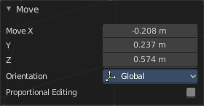
Last Operator Move

Move X, Y Z
The position. Attention, the actual world orientation and rotation does not matter here. It always starts with a value of zero, and moves relative to this zero then. For the actual location values have a look in the sidebar in the transform panel.

Orientation

The widget can have different orientations. The menu items should be self explaining.


Proportional editing
Enables proportional editing. Activating proportional editing reveals further settings.

Proportional Falloff
Here you can adjust the falloff methods.

Proportional Size
Here you can see and adjust the falloff radius.

Connected
The proportional falloff gets calculated for connected parts only.

Projected(2D)
The proportional falloff gets calculated in the screen space. Depth doesn't play a role. When it's in the radius, then it gets calculated.

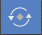
Rotate
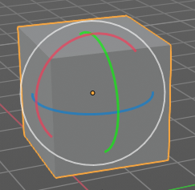
Activates the Rotate tool. Activating the move tool also reveals a rotate widget at the object. This widget allows you to rotate the object, by using the corresponding axis.

Snapping
Holding down Ctrl activates temporary global snapping.

Precision rotation
When you hold down shift, then you will have a much slower but also much preciser rotation.

Header Values
When you rotate your object then you will see some values in the header, which defines the current rotation of the object. The rotation is shown in degrees.

Rotate without widget
You don't have to use the widget to rotate the object. You can also click asides and drag the selection around.

Limit Axis
When you want to rotate a specific axis, then press X or Y to limit the rotation to this axis.
By holding down the mouse button and pressing the X, Y or Z key twice you can toggle this to local. But also to other orientations. This depends in what orientation you start. With normal you can toggle that way between Normal and Global.

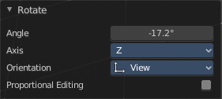
Last Operator Rotate

Angle
The rotation. Attention, the actual world orientation and rotation does not matter here. It always starts with a value of zero, and rotates relative to this zero then. For the actual rotation values have a look in the sidebar in the transform panel.

Axis
Which axis to rotate.

Orientation
The widget can have different orientations. The menu items should be self explaining.

Proportional editing
Enables proportional editing. Activating proportional editing reveals further settings.

Proportional Falloff
Here you can adjust the falloff methods.

Proportional Size
Here you can see and adjust the falloff radius.

Connected
The proportional falloff gets calculated for connected parts only.

Projected(2D)
The proportional falloff gets calculated in the screen space. Depth doesn't play a role. When it's in the radius, then it gets calculated.


Scale
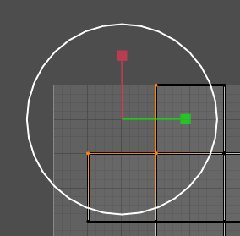
Activates the Scale tool. Activating the scale tool also reveals a traditional scale widget at the object. This widget allows you to scale the object, by using the corresponding axis. When you click at the outer white circle and drag, then you can scale the object uniformly.
The rectangle buttons between the arrows allows you to scale in direction of the adjacent arrows. This can also be done by clicking at the tip of the arrow and holding down shift. Then you can scale the cube along the two other axis.

Snapping
Holding down Ctrl activates temporary global snapping.

Precision Scale
When you hold down shift, then you will have a much slower but also much preciser scale.

Header Values
When you scale your object then you will see some values in the header, which defines the current scale of the object.
These values are always relative to the starting point. You always start with 1, regardless of the real world scale.

Scale without widget
You don't have to use the widget to scale the object. You can also click asides and drag the selection around.

Limit Axis
When you want to rotate a specific axis, then press X or Y to limit the scale to this axis.

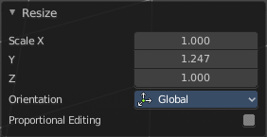
Last Operator Resize

Angle
The rotation. Attention, the actual world orientation and rotation does not matter here. It always starts with a value of zero, and rotates relative to this zero then. For the actual rotation values have a look in the sidebar in the transform panel.

Axis
Which axis to rotate.

Orientation
The widget can have different orientations. The menu items should be self explaining.

Proportional editing
Enables proportional editing. Activating proportional editing reveals further settings.

Proportional Falloff
Here you can adjust the falloff methods.

Proportional Size
Here you can see and adjust the falloff radius.

Connected
The proportional falloff gets calculated for connected parts only.

Projected(2D)
The proportional falloff gets calculated in the screen space. Depth doesn't play a role. When it's in the radius, then it gets calculated.

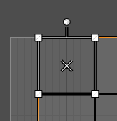
Transform
Transform reveals a multi transform widget with all three transform methods available at once. Move, Rotate and Scale.
The rules are the same than for the single tools, and also the last operators. Dependant of which widget part you pull here. So i won't go into detail again here.
Clicking into the area of the widget allows you to move the selection.
Grabbing the sticking out round circle part allows to rotate the selection.
Grabbing one of the corner points allows you to scale the selection.

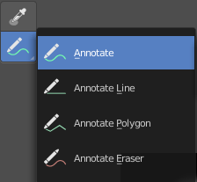
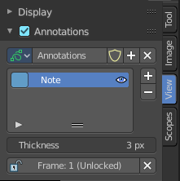
Annotate Tools group
The annotation tool is available in multiple editors. With this tool you can write notes at the screen. The annotate tools is the little brother of the grease pencil objects.
Further settings for annotate can be found in the sidebar. Here you can also remove an annotation when you don't longer need it. And here you can also adjust the size of the stroke.
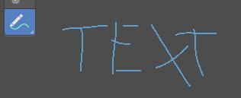

Annotate
Draw free-hand strokes in the main window.

Annotate Line
Click and drag to create a line.

Annotate Polygon
Click multiple times to create multiple connected lines. The current polygon is finished when Esc or RMB is pressed.

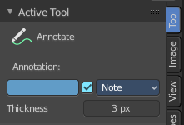
Tool Settings
The tool settings for Annotate, Annotate Line and Annotate Polygon are the same. Different from the 3D view, there is no placement option for the 3d cursor.

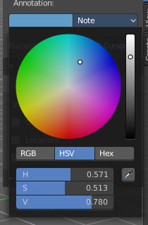
Color
Clicking at the left color field reveals a color picker where you can define the color for the annotation stroke.

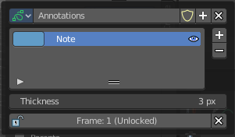
Note
Clicking at the Note dropdown box reveals a panel with further settings. It's the same content than in the annotations in the View tab.

Annotations list

Here you can add, remove and rename new annotations.

Edit Box
The name of the current annotation. You can rename the annotation to your needs here.

Fake User
Assign a fake user to this annotation. Fake users is a odd concept to keep data in the scene even if it has no user somewhere. The fake user is then a dummy user so that the object is not deleted when saving the scene.

Add Annotation
Add a new annotation.

Unlink Annotation
Delete the annotation.

Thickness
The thickness of the annotation stroke.

Frame Locked/Unlocked
Lock frame displayed by current layer. This toggles whether the active layer is the only one that can be edited.

Delete Active Frame
Deletes the active frame from the active grease pencil layer.

Thickness
The thickness of the annotation stroke.

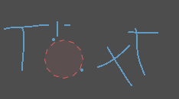
Annotate Eraser
Click and drag to remove annotate lines.

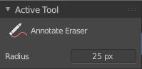
Tool Settings

Radius
The radius of the eraser pencil.

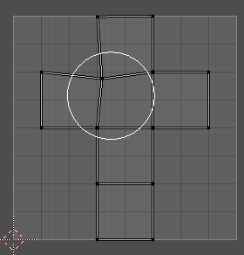
Grab
This is a brush tool that has further settings in the Tool tab in the sidebar at the right. Grab allows you to grab and move the geometry under the brush.
The brush radius can be changed with hotkey F. See also the Tool settings in the Brush panel.

Relax
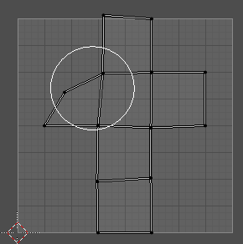
This is a brush tool that has further settings in the Tool tab in the sidebar at the right. Relax allows you to relax the geometry under the brush. The vertices are more evenly distributed.
The brush radius can be changed with hotkey F. See also the Tool settings in the Brush panel.

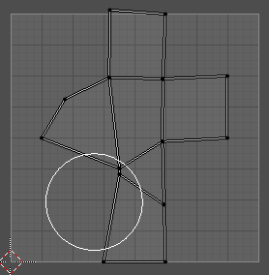
Pinch
This is a brush tool that has further settings in the Tool tab in the sidebar at the right. Pinch allows you to pinch the geometry under the brush. The vertices comes closer to each other.
The brush radius can be changed with hotkey F. See also the Tool settings in the Brush panel.

